Vaulting Camp!
Ages 5-10
Make new friends and explore the wonderful world of Equestrian Vaulting. Activities include: hands on horse experiences, equestrian vaulting, dance, gymnastics, games, crafts, and horsemanship. Show on the last day!
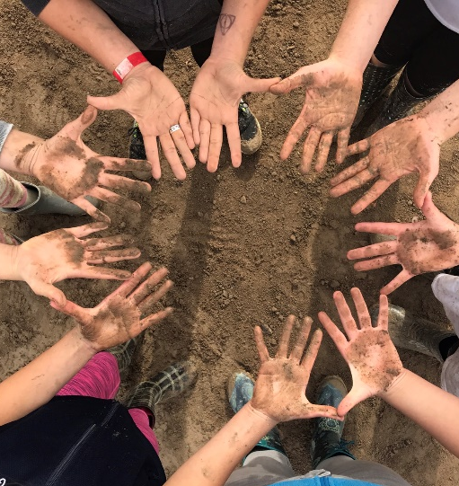

9am $299
Sign up at ocvaulting.com
June 26-29th
July 10-13th
July 24-27th

